50 years of MODERSOHN® — Because postponed is not abandoned!

**Spenge.** **The company** **Wilhelm Modersohn GmbH & Co. KG, manufacturer and processor of façade fastening systems and customized constructions made of stainless steel and Lean Duplex steel, finally celebrated its 50th anniversary on the 16th and 17th of June after a delay of 3 years.**

The former family company situated in the east westphalian town Spenge was family-owned by Wilhelm Modersohn until February 2023 and is now part of Leviat. Leviat, a CRH company, is a global leader in connecting, fixing, lifting and anchoring technology for the construction industry, supplying a variety of market sectors from residential to infrastructure. Due to the change of ownership in February, Wilhelm Modersohn sets after 53 years a new course for the flourished future of the traditional company.

According to this circumstances, Modersohn took the delayed festivities as an opportunity to introduce the new parent company to the customers, suppliers, consulting companies and cooperative partners.

Among the congratulators were also representatives of the local political groups. On Friday Ingeborg Balz, the Deputy District Administrator of Herford and on Saturday Bernd Dumcke major of the town Spenge spoke a very emotional speech of Modersohn as an economic and social supporter of the town.   
The guests as well as the employees were very delighted and in full admiration for Wilhelm Modersohn Senior (94) and his wife, once for taking part at the celebrations and secondly for the work done by the previous generation.

According to the management, 50 years of Modersohn should not simply end in a "bash". Rather, Mr. Modersohn wanted to make a clear statement to underline his commitment to the company and the values Modersohn stands for. And so the motto became an example.

„Sustainability is the central topic of our celebration”, clarified Wilhelm Modersohn with his opening speech. And furthermore he introduced honorable speakers from the area of industry, economy and research, who showed their expertise of renewable energy, sustained raw materials and their importance for the industry, economic and construction field in highly interesting lectures. Modersohn welcomed the lecture speakers M.Sc./Dipl.-Ing. Oliver Heins from the company Energy Baden-Württemberg (EnBW), Mrs. Doris Orant and Dr.-Ing. Sebastian Heimann from the Stainless Steel Information Centre (ISER) in Düsseldorf, Dipl.-Ing. (FH) Jens Lehmann from the Federal Institute for Materials Research and Testing (BAM) in Berlin, M.Sc. Thomas Schöb from the Jülich Research Institute and Dr.-Ing. Matthias Roik from the company Leviat.

„Mr. Modersohn has always been very passionate about the cause “, told one of the guests Mrs. Vivian Dieckmann, head of Marketing at Modersohn, and underlined that within the framework of the event the competence and the passion of Modersohn in materials, the progress and the environment was also shown. Perfectly demonstrated was this statement with the in-house exhibition of Modersohn. Several departments, serial products and special constructions as well as parts of the production processes were presented by Modersohn.

After the professional lectures, within the brightest sunshine the guests relaxed in the lounge and outdoor areas which appeared with their green plants very tropical. With a cold drink and a delicious meal, the guests celebrated until the early evening.

The summary of all the people involved: Modersohn celebrated duly the past, present, and future of the company!

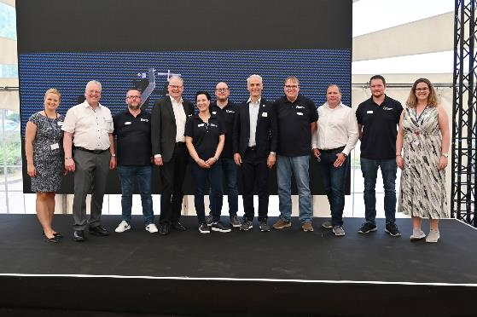

IMG 1: The past, present and future of Wilhelm Modersohn GmbH & Co. KG was celebrated at the weekend.

Pictured (from left to right): Nicole Paschek (HR Manager at Leviat), Wilhelm Modersohn (Managing Director of Wilhelm Modersohn GmbH & Co. KG), Tobias Skarupke ( Head of Department Special Construction & Industrial Components at Modersohn), Guido Lange (Head of Human Resources | Central Europe & Central Operations at Leviat), Vivian Dieckmann (Head of Department Marketing at Modersohn), Dennis Berghoff (Head of Department Facade Fixings for Concrete at Modersohn), Mehmet Pekarun President of Leviat Company), Reinhold Hübers (Head of Controlling at Modersohn), Jürgen Matzelle (Technical Managing Director at Modersohn), Florian Berthold (Head of Department Facade Fixings for Masonry at Modersohn), Jacqueline Wüster (HR Manager at Leviat), Photo: Andrea Deppe, © 2023 Wilhelm Modersohn GmbH & Co. KG (part of Leviat)

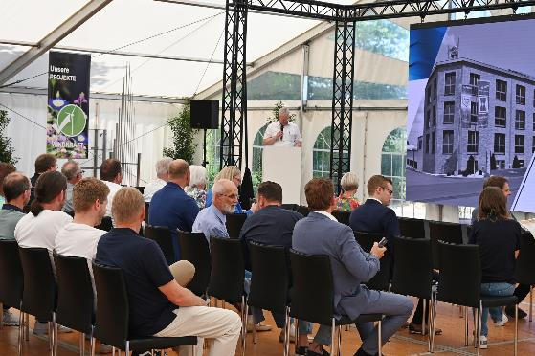

IMG 2: Opening speech by Wilhelm Modersohn on the occasion of the 50th anniversary of the company Wilhelm Modersohn GmbH & Co. KG.

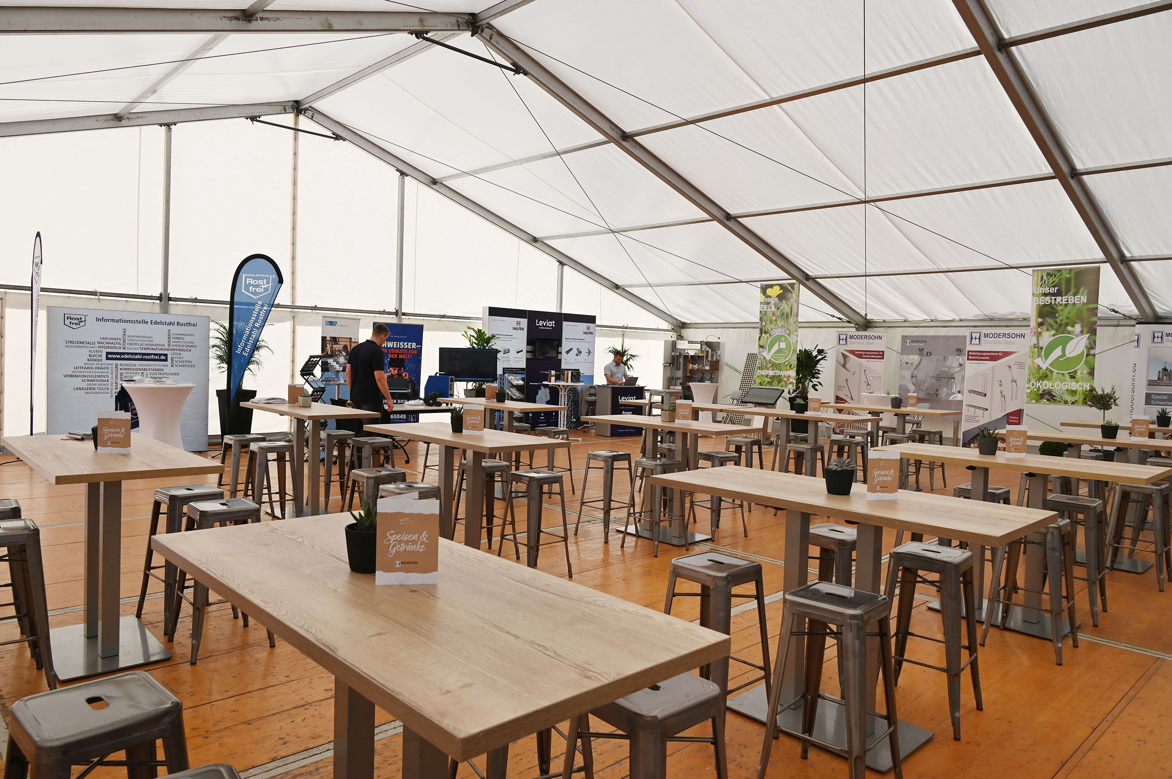

IMG 3: An in-house exhibition with cooperating companies was also realised by Modersohn.

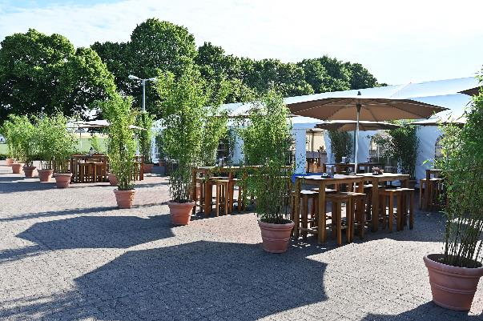

IMG 4:. The wonderful weather and the outdoor area with green plants were very inviting to stay and relax.

Here you can download the press release and high-resolution images:

https://www.modersohn.eu/wissenswertes/aktuelles/detailseite/50-jahre-modersohn-gefeiert/

**Contact person:**

**Wilhelm Modersohn GmbH & Co. KG (part of Leviat)**

Vivian Dieckmann

Marketing-Manager

Industriestraße 23

32139 Spenge

T: +49 5225 8799-472 | F: +49 5225 8799-45

email: v.[dieckmann@modersohn.de](mailto:dieckmann@modersohn.de) | internet: [www.modersohn.eu](http://www.modersohn.eu)