MODERSOHN® - Interactive exhibition appearance at BAU 2023 in Munich
Spenge/Munich. Wilhelm Modersohn GmbH & Co. KG, manufacturer and processor of facade fastening systems and special constructions made of stainless steel and Lean Duplex steel, presented itself from a completely new side at BAU 2023 from 17 to 22 April. The Modersohn stand concept followed the trend of the digital age and allowed visitors to interactively explore Modersohn's product and company world via various multi-touchscreen stations.
Away from the classic product exhibition, which in previous years focused on the large number of articles, this year the focus was also specifically directed towards three exhibits, characteristic of the main sales and production areas of the Speng company. Representative of the areas of facade fastening systems for masonry, concrete and the production of special constructions, three exhibits made of stainless steel and Lean Duplex steel were impressively illuminated on the trade fair wall at the joint stand of Informationsstelle Edelstahl Rostfrei (ISER). The adjustable MOSO® FB-HJ suspended tie rod for fastening precast concrete façades and the MOSO® EK-D single bracket with adjustable pressure screw for fastening facing façades, with their movable adjustment options, were particularly effective.
The miniature special component of the NiroFix® department was also an eye-catcher. The heavy-duty fastening made of the materials 1.4571 and 1.4162 was custom-made for a public building. The installation part is around six times larger in its original state and compensates for movements in the façade that can occur for thermal reasons.
In 3D manner, the three fixed brackets gave the impression during the animation of detaching from the wall and disassembling into their individual parts.
The bracket anchors for the area of façade fastening were also given a special showcase at BAU 2023 in Munich at the Leviat stand in Hall A3. Since February 2023, Modersohn has been part of Leviat, a CRH company that supplies a wide range of market sectors worldwide, from residential construction to infrastructure, as a leading supplier of connection, fastening, lifting and anchoring technology for the construction industry.
"At this year's BAU 2023, we were very pleased to be able to present for the first time with a general building authority approval our solution of thermal separation for facing facades in the system with our support anchor heads for the type-tested MOSO® brackets," reports Jürgen Matzelle, technical managing director at Modersohn. "Thanks to the property of high pressure resistance, the "MOSOTherm" hole plates made of glass-fibre reinforced plastic can permanently absorb high bearing loads and demonstrably reduce thermal bridges in the area of the metallic fixings in the concrete and in the double-shell wall structure," the graduate civil engineer explains further.
Trade visitors can find out more about Modersohn's products from 20 to 22 June at the 67th BetonTage in the Congress Centrum Ulm. Here, Modersohn's façade fixings for concrete department will present sustainable solutions, in keeping with the theme of Europe's largest trade congress of the concrete and precast industry, which this time is all about the turning point in concrete construction.
Further information also available at: www.modersohn.eu/en
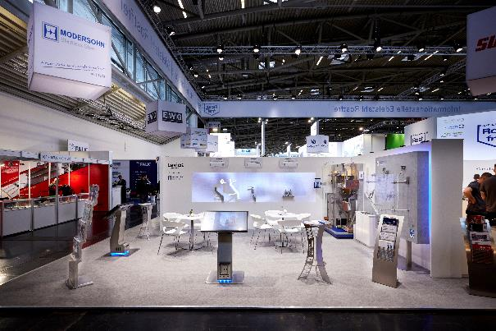
Image 1: Interactive exhibition stand of Wilhelm Modersohn GmbH & Co. KG (part of Leviat) at BAU 2023 in Munich.
Photo: Tom Jasny, © 2023 Leviat GmbH.

Image 2: Product presentation with animated light installation. Photo: Tom Jasny, © 2023 Leviat GmbH.
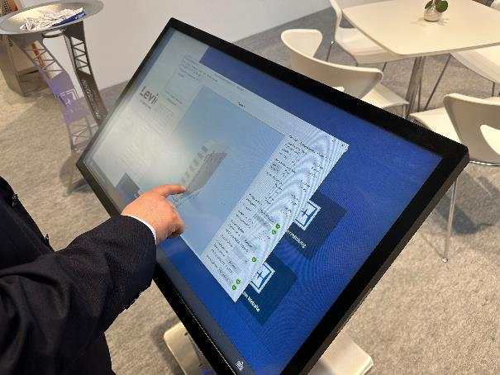
Image 3: The interactive multi-touch screens offered visitors to the stand the opportunity to try out the dimensioning software and mass determination developed by Modersohn.

Here you can download the press release and image data:
https://www.modersohn.eu/en/worth-knowing/news/detailpage/follow-up-to-bau-2023/

Contact:
Wilhelm Modersohn GmbH & Co. KG (Part of Leviat)
Vivian Dieckmann
Head of Marketing

Industriestraße 23
32139 Spenge
T: +49 5225 8799-472 | F: +49 5225 8799-45
e-mail: v.dieckmann@modersohn.de | Internet: www.modersohn.eu/en

