MODERSOHN® Stainless Steel: Market presence 2022 as strong as never before

Spenge. Wilhelm Modersohn GmbH & Co. KG relies on a strong market presence in times of crisis.
In times like these, it is more important than ever for manufacturing companies to maintain and strengthen their customer relationships. "With stability, reliability and an unwavering presence, we want to confirm to our customers the trust they need to place in us for their project business," justifies Wilhelm Modersohn, managing director and owner of the stainless steel processing company. Neither the pandemic nor the shortage of materials were able to divert the company from its continuing course of success last year.
Thus, the 2021 financial year, with a record turnover of just under 22 million euros, saw an increase in turnover of 16 %. "In the last 20 years, we have quadrupled our turnover, and we have invested the profit primarily in the expansion of our site, in new machinery and equipment and, last but not least, in qualified personnel," reports W. Modersohn, looking back wistfully to the old days. "In 1970, my father, Wilhelm Modersohn senior, founded the company and started producing the first MU anchor in a chicken coop. He only had two employees, and I helped out with pre-assembly when I was a boy." Today, Modersohn is one of Europe's largest suppliers in the field of manufacturing and distributing heavy-duty fasteners for masonry and precast concrete façade systems, made of stainless steel and Lean Duplex steel. With 145 employees, the company manages to constantly expand its area of expertise and thus also its market position.
The manufacturer's market presence abroad is also to be further expanded. Proactive investments for 2022 will focus on the expansion of digital technologies. Even better IT security systems and specially created multilingual software programmes and interfaces will ensure more effective and sustainable customer relations.
The online shop for fastening accessories and standard parts made of duplex steel was already launched in August 2021 and is to be established more intensively this year as a special customer service.
With its own test laboratory, including a test engineer and test equipment for comprehensive material analyses and product tests such as hardness, roughness, sealing and mechanical load tests, quality assurance at Modersohn was also significantly strengthened last year in favour of customer satisfaction.
Sustainability of Modersohn products is also a topic that will be made transparent for the business customers of Wilhelm Modersohn GmbH & Co. KG. Environmental product declarations are currently being prepared for the most popular products, the MOSO® support anchor brackets and the MBA CE anchor channel. The proof of a so-called EPD (Environmental Product Declaration) is increasingly requested by architects and planning offices in the field of sustainable building, for the construction of "green houses".
One can also look forward to the introduction of product innovations and further developments. In addition, the company announces that further investments in new production machines and the construction of additional production halls are already being planned for 2023.
Company description:
Wilhelm Modersohn GmbH & Co. KG is known in the field of stainless steel processing and the production of fastening elements above all for manufacturing series and special products from high-alloy and special stainless steels. For years, the company has been focusing on duplex steels, in particular the so-called "Lean Duplex" steels (1.4062, 1.4162, 1.4362), whose market launch in the German construction industry has been personally championed by Managing Director W. Modersohn since 2002.

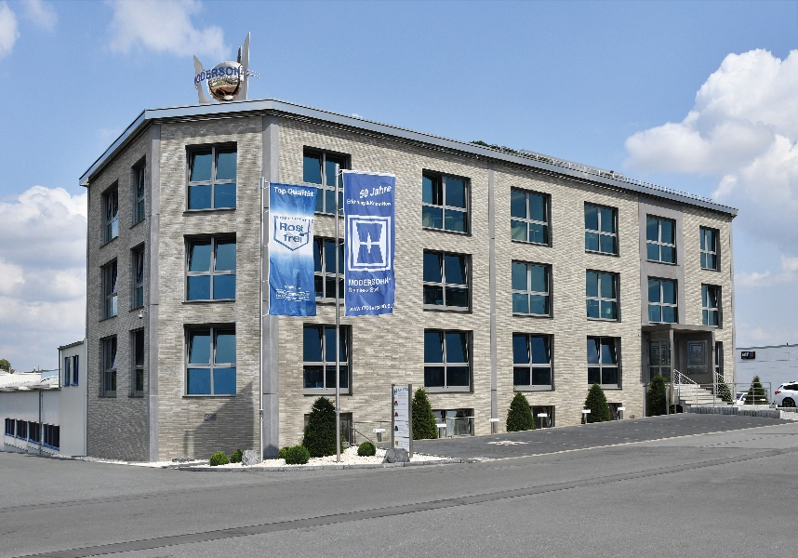
Captions:
Image 1: Wilhelm Modersohn, Managing Director of Wilhelm Modersohn GmbH & Co. KG
Image 2: MODERSOHN® Stainless Steel, headquarter in Spenge
Download image and text files at:
https://www.modersohn.eu/en/worth-knowing/news/detailpage/modersohnr-stainless-steel-market-presence-2022-as-strong-as-never-before/
Contact:
Wilhelm Modersohn GmbH & Co. KG
Vivian Dieckmann
Head of Marketing
Industriestraße 23
32139 Spenge
T: +49 5225 8799-472 | F: +49 5225 8799-45
E-Mail: v.dieckmann@modersohn.de | Internet: www.modersohn.eu

